**Radio Control Panel (RCP)**

# Geoff Anderson G3NPA, Jim Hargrave W5IFP, Javier Bermejo EA1AUS and Aki Yoshida JA1NLX

## 1.0 GENERAL

The basic Radio Control Panel (RCP) is shown below. It consists of two parts, the upper panel to display either a waterfall or spectrum representation of the received audio, and the lower panel consists of 12, 24, 36 or 48

user definable Macro buttons for the control of the radio via the [CAT](#CAT) interface.

You should be able to control the RCP with function keys directly (on the RCP), from the [Logbook Entry window](#_topic_LogbookEntryWindow) (if the [CW Machine](#_topic_CWMachineWindow), [Sound Card Data window](#_topic_SoundCardDataWindow1), [Data Terminal](#_topic_DataTerminalWindow) and [DVK](#_topic_DigitalVoiceKeyerDVK) windows are closed), and if the global function key capture is enabled from any application anywhere on the screen.

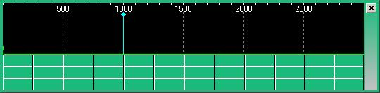

RCP\_1

This is an example how it displays with typical settings. Details are described below.

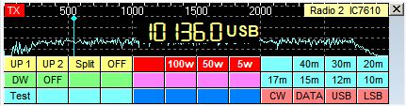

RCP\_1A

By design there is no header line to the window but instead this appears to the right hand side of the buttons/spectrum display areas. Access to this window is obtained in one of two ways:

1. By using the Logger32 [Main menu](#_topic_MainMenu) [View | Show radio control panel](#4.0_VIEW_MENU_ITEM) menu items; or,

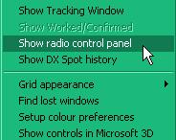

RCP\_2

1. or right-clicking on the [Radio panel](#3.4_Radio_Control_Status) on the [Lower Status bar](#3.0_LOWER_STATUS_BAR) and selecting the same option.

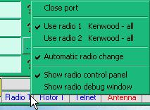

RCP\_3

## 2.0 MENUS

To obtain the set up menus associated with the Radio Control panel, right-click on the side bar.

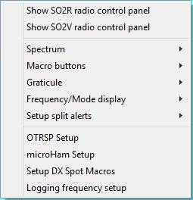

RCP\_4

### 2.1 Spectrum

Select the Spectrum | Setup spectrum audio menu items.

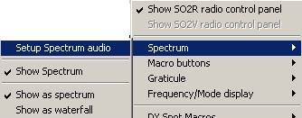

RCP\_4A

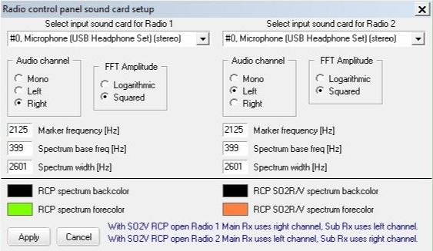

New RCP\_5

On this set up panel the user can select the sound card to use for Radio 1 and Radio 2, the spectrum color options, the frequency marker position, the audio channel to use, the spectrum width (values between 500 -3000) and the FFT amplitude.

**Note**: If the user does not have a sound card installed, or does not desire to display the audio spectrum, uncheck the option: “Show audio spectrum when RCP opens”

The Spectrum base can be set from 0-399 Hz. This allows the display to be expanded starting at the Spectrum base frequency. The maximum allowable total spectrum width is 3000. In the above example the Spectrum base is set to 300, so the maximum width becomes 2700 (Base plus width).

Example: if the VFO is set to 14.100.0 Mhz, the frequency scale will display from 14.100.3 to 14.103.0.

**Show spectrum** (panel)

This option allows the user to show or hide the spectrum panel. If this option is unchecked just the Macro buttons will be displayed.

**Show as spectrum / waterfall**

The option selects either a spectrum or waterfall display.

### 2.2 Macro Buttons

Each Radio Control Panel has its own set of Macros. The user can select 0, 12, 24, 36 or 48 macro buttons for each of these panels.

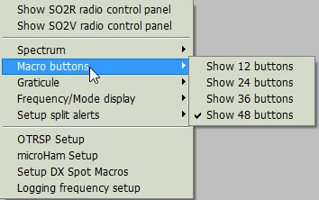

RCP\_5A

### 2.3 Graticule

Select between displaying the radio VFO or audio frequency.

### 2.4 Frequency/Mode display

### Check “Show Frequency/Mode display” to show frequency/mode on RCP. Mode is forced to set “USB” automatically when operating FT8/FT4.

### RCP_5B

RCP\_5B

Click “Frequency/Mode appearance” to setup various options.

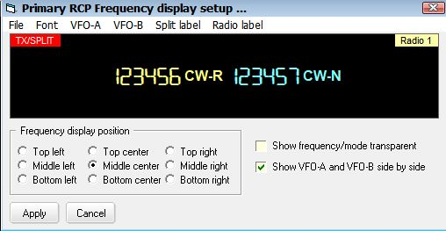

RCP\_5C

### 2.5 ~~2.4~~ Setup DX Spot Macros

Select “Setup DX Spot Macros” from the main RCP Menu. See #dxspotsplit# function below for much more detaIL.

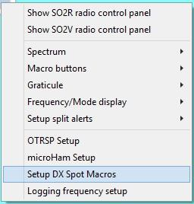

RCP\_6

### 2.6 ~~2.5~~ Setup split alerts

The following options allow the user to setup Audible and Visual alerts when Split mode is enabled. It also allows for enabling automatic split mode options and Clear split Macro on QSY.

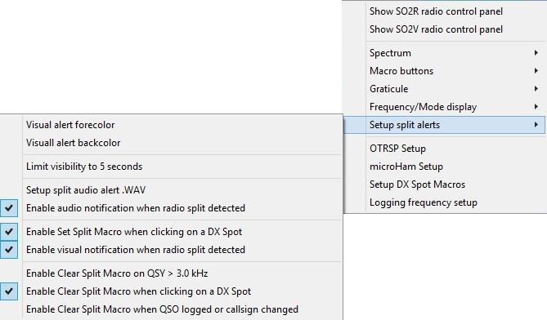

RCP\_6A

### 2.7 ~~2.6~~ Logging frequency setup

This option provides the user with several logging options when operating in Split mode.

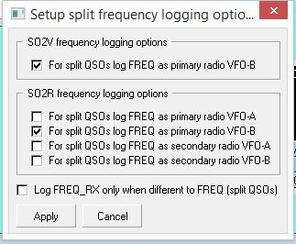

RCP\_6B

## 3.0 MACRO BUTTONS

Setting up these buttons is exactly the same as is described in the [Programmable Buttons](#_topic_ProgrammableButtons) topic.

**Note** however that the list of Macros designed for use in the [CW Machine](#_topic_CWMachineWindow) and the [Sound Card Data wiindow](#_topic_SoundCardDataWindow1) do not apply here except for those detailed below. The primary use of these buttons is for the control or parameter changing of the actual radio in use so the basic Macros of [$command$](#$command$) and [$hexcommand$](#$hexcommand$) are the main ones to use here.

There is a set of Macro buttons for each of the definable radios. This allows for the single radio user to employ up to 72 macro buttons by setting Radio 2 CAT parameters to the same as Radio 1 and using the <**Ctrl+T**> key combination to swap radios, providing a second set of 36 buttons.

## 4.0 MACROS AND FUNCTIONS IN THE RCP

### 4.1 Macros

The following Macros are available in the RCP.

|  |
| --- |
| **Macro** |
| [$clearlog$](#$clearlog$) |
| [$ClearCallsignOnQSYOn$](#$ClearCallsignOnQSYOn$) |
| [$ClearCallsignOnQSYOff$](#$ClearCallsignOnQSYOff$) |
| [$ClearQSYMarker$](#$ClearQSYMarker$) |
| [$command$](#$command$) |
| [$greeting$](#$greeting$) |
| [$hexcommand$](#$hexcommand$) |
| [$IcomVFOB$](#$IcomVFOB$) |
| [$logimmediate$](#$logimmediate$) |
| [$Mouse TF-Set$](#$mouseTF-Set$) |
| [$qsy(nn)nnn.(nn)$](#$qsy(nn)nnn.(nn)$) |
| [$radio1$](#$radio1$) |
| [$radio2$](#$radio2$) |
| [$Radio1Offset xxxxx$](#$Radio1Offset_xxxxx$) |
| [$Radio2Offset xxxxx$](#$Radio2Offset_xxxxx$) |
| [$radio1->radio2$](#$radio1->radio2$) |
| [$radio2->radio1$](#$radio2->radio1$) |
| [$SlavePortClose$](#$slaveportclose$) |
| [$SlavePortOpen$](#$slaveportopen$) |
| [$so2r$](#$so2r$) |
| [$so2v$](#$so2v$) |
| [$so2von$](#$so2von$) |
| [$so2voff$](#$so2voff$) |
| [$splitaudioalert$](#$splitaudioalert$) |
| [$splitvisualalerton$](#$splitvisualalerton$) |
| [$splitvisualalertoff$](#$splitvisualalertoff$) |
| [$TF-Set$](#$TF-Set$) |
| [$toggleradios$](#$toggleradios$) |
| [$uham xx$](#$uham_xx$) |
| [$wait x$](#$wait_x$) |

4.2 Functions

The following functions are available in the RCP:

|  |  |
| --- | --- |
| **Function** | **Description** |
| #call# |  |
| #dxspotsplit# |  |
| #greeting# | Send a greeting appropriate to the local time of the QSO partner. If Logger32 cannot determine the distant end time, then the default greeting will be sent. See the [Macros topic](#_topic_MACROS) for information on setting up the default greetings.  **Note**:: This function is only available for radios that accept CW keying information by CAT commands. Syntax would be something like:  $command BLAH #greeting# BLAH$$logimmediate$ |
| #keyboard# | This function, when imbedded in a Macro, will allow the user to increment the selected VFO by the amount keyed In via the keyboard. An example is  $hexcommand FE FE 04 E0 05 #keyboard# FD$ Increments IC-735 active VFO “n” kHz  The keyboard entry is nominally two digits and the number must be in whole kHz. Plus (up) is assumed, however you can increment it down by adding a <minus sign> preceding the number ( -5).  There is a fixed 5-second delay to allow keyboard action. However, if 2 digits (as in 05 or 10) are entered the execution is Immediate. |
| #mode# | When using any of the [#split#](##splitxxx#) type functions, it is important to make sure that the complete Macro sets the MODE of the VFOs to be the same.  **Note**: The #mode# function is a single digit function. Where the radio setmode is two digits, the user must configure the Macro to include the leading “0” or other digit as required.  An example is Yaesu FT-920 sets VFO-A with: 00, 01, 02 ,03 etc and VFO-B with: 80, 81, 82, 83.  A Macro to set VFO-B mode must have a leading “8”. The Macro would be like this:  $hexcommand 00 00 00 8#mode# 0C$  In most of the modern radios there is a simple CAT function that will do this called A>B which will set the freq and the modes to be the same. However in some of the more vintage radios there may not even be a button to do this or the button is there but there is no matching CAT command. The #mode# function can possibly help here for it can take the mode of the A VFO and make the information available to be pushed back into the B VFO.  In the case of the TS-850 for example one could use this function:  $command FR1;$ Swap to VFO B  $command MD#mode#;$ Make MODE same as VFO A  **Note**: When constructing a full Macro using this function you MUST swap VFOs before and after. |
| #modeModifier# | Sends a bandwidth command to the radio when a split command changes the operational mode.  Basic syntax is like the #split# function: $command xx xx #modeModifier# xx$.  See paragraph 6.3 for detailed use of this function. |
| #mycall# | Inserts the current "operator" value into the output text stream. Usually this would be a callsign.  **Note**: Only available for Radios that accept keying information when in CW mode. |
| #name# | Inserts the contents of the Name field currently displayed in the Logbook Entry window into the output text stream.  **Note**: Only available for Radios that accept keying information when in CW mode. |
| #sentrst# | Inserts the contents of the RST\_SENT field in the Logbook Entry window. If the field is empty, the #sentrst# modifier will default to to 599. |
| #splitxxx# | An additional feature in the Radio Control Panel (RCP) is a #split# function for use within these Macros (in the RCP only), The purpose of this function when embedded in a Macro string is to insert a frequency based on the current VFO frequency, and to format that frequency for the command and radio in use.  The basic syntax is #splitxx# xx is a frequency offset in KHz. For example, to shift the VFO frequency up 10KHz the syntax would be #split+10#. To shift the VFO down 5KHz, the syntax would be #split-5#. The frequency string that the function generates is formatted for a $command xxxx$ Macro specific to the radio in use.  The frequency string the function generates is in KHz regardless of the radio type. |
| #splitxxxh# | The“h” specifies the command in which the function is embedded. If the #split function is embedded in a $hexcommand xxxx$ Macro, the syntax is #splitxxxh# the frequency string that the function generates is in hex and is formatted for the particular radio in use, |
| #splitxxxq# | If the #split# function is embedded in a $qsy xxxx$ Macro.  The correct syntax is #splitxxxq#.  **Note**:- The #splitxx# function has been simplified and the #splitxxxq# and #splitxxxh# functions no longer require the "q" or the " h". It is not mandatory to rewrite these Macros, but it is no longer necessary to use the q or h modifier. .  If the #split# function is embedded in a $qsy xxxx$ Macro.  The correct syntax is #splitxxxq#. |
| #spleeetxxx# | As part of the ongoing multi-lingual efforts of Logger32, the #splitxxx# function has been expanded. #spleeetxxx# is now acceptable This variation can be used interchangeable with the above listed #splitxxx# commands. |
| #wait n# | Used in conjunction with $command ... $ Macro. The syntax is $command #wait n# xyz;$ or $hexcommand #wait n# xx yy zz$. Executing these commands will pause n seconds then execute the command xyz or hexcommand xx yy zz  Examples:  $command do this first;$  $command #wait xx# do this next after waiting xx seconds;$  $command #wait xx# do this last after waiting xx seconds;$  #wait5# or #wait 5# should both work. |

### 4.3 Examples of Simple Macros

Also see the topic [Direct Control of Radios](#_topic_DirectControlofRadios).

### 4.3.1 ICOM Macros

This is the Macro to change an ICOM VFO to 14123.456:

$hexcommand FE FE 74 E0 05 56 34 12 14 FD$. The red text is the frequency formatted in hex just like ICOM likes to see it.

Say that your ICOM is on 14001.234 and you want to QSY the VFO +10KHz, the Macro is:

$hexcommand FE FE 74 E0 05 #split+10h#FD$

The split function will read the VFO frequency from Logger32, add 10KHz to it, and convert it to hex in the required ICOM format. In this example, the output of the function is 34 12 01 14 this is then inserted into the Macro to replace the #split# function. The Macro now looks like this $hexcommand FE FE 74 E0 05 34 12 01 14 FD$ which will move the VFO to 14011.234 (up 10).

### 4.3.2 Radios that accept keying information when in CW mode

In addition to commands and functions effecting the frequency and radio selection control it is possible to use a limited number of functions when using CW for those radios that will accept keying information directly via the CAT interface.

These functions would be used something like:

$(hex)command TXON; SCW;#call# de #mycall# Hi #name# ur 599 ok bk;$

$(hex)command TXOFF;$

Where:

TXON is the command to put the radio in TX; and,

SCW is the command to send CW and TXOFF put the radio in RX.

#call# and #name# are replaced by entries in the Logbook Entry Window (if it is open) and #mycall# is replaced by the current operator.

An example for the K3/KX3 might be:-

$command KY #call# Hello #name#;$ or

$command KY 73 #mycall# \*;$

**Note** - these functions will only work with radios that will accept keying text via the CAT interface.

### 4.3.3 A set of simple Macros for the IC-7600 and IC-756 Pro III together with a suggested use in the RCP

|  |  |  |
| --- | --- | --- |
|  | **ICOM IC-7600 (hex address 7A)** | **ICOM IC-756 Pro III ( hex address 6E)** |
| **Mute** | $hexcommand FE FE 7A E0 14 01 00 FD$ | $hexcommand FE FE 6E E0 14 01 00 FD$ |
| **AF Volume 30** | $hexcommand FE FE 7A E0 14 01 30 FD$ | $hexcommand FE FE 6E E0 14 01 30 FD$ |
| **AF Volume 50** | $hexcommand FE FE 7A E0 14 01 50 FD$ | $hexcommand FE FE 6E E0 14 01 50 FD$ |
| **USB** | $hexcommand FE FE 7A E0 06 01 FD$ | $hexcommand FE FE 6E E0 06 01 FD$ |
| **LSB** | $hexcommand FE FE 7A E0 06 00 FD$ | $hexcommand FE FE 6E E0 06 00 FD$ |
| **RTTY** | $hexcommand FE FE 7A E0 06 04 FD$ | $hexcommand FE FE 6E E0 06 04 FD$ |
| **CW** | $hexcommand FE FE 7A E0 06 03 FD$ | $hexcommand FE FE 76E E0 06 03 FD$ |
| **Split On** | $hexcommand FE FE 7A E0 0F 01 FD$ | $hexcommand FE FE 6E E0 0F 01 FD$ |
| **Split Off** | $hexcommand FE FE 7A E0 0F 00 FD$ | $hexcommand FE FE 6E E0 0F 00 FD$ |
| **A=B** | $hexcommand FE FE 7A E0 07 B1 FD$ | $hexcommand FE FE 6E E0 07 B1 FD$ |
| **A/B** | $hexcommand FE FE 7A E0 07 B0 FD$ | $hexcommand FE FE 64 E0 07 B0 FD$ |
| **14.195 SSB** | $qsy 14195$ $hexcommand FE FE 7A E0 06 01 FD$ | $qsy 14195$ $hexcommand FE FE 6E E0 06 01 FD$ |
| **Split Up 5** | $qsy #split+05q#$ | $qsy #split+05q#$ |
| **Split Down 10** | $qsy #split-10q#$ | $qsy #split-10q#$ |
| **NB On** | $hexcommand FE FE 7A E0 16 22 01 FD$ | $hexcommand FE FE 6E E0 16 22 01 FD$ |
| **NB Off** | $hexcommand FE FE 7A E0 16 22 00 FD$ | $hexcommand FE FE 6E E0 16 22 00 FD$ |
| **Dual Watch On** | $hexcommand FE FE 7A E0 07 C1 FD$ | $hexcommand FE FE 6E E0 07 C1 FD$ |
| **Dual Watch Off** | $hexcommand FE FE 7A E0 07 C0 FD$ | $hexcommand FE FE 6E E0 07 C0 FD$ |

**Note**: If the function exists for the ICOM transceiver, note that the only difference in the hex command between all ICOM radios (not IC-735), is the third byte of the hexadecimal command, the default address hex for each ICOM radio.

**and the way EA1AUS uses these in the RCP is shown below**

**Icom IC7600**

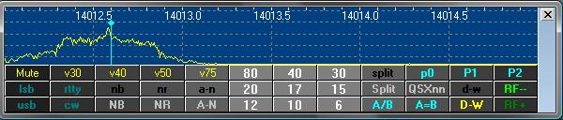

RCP\_7

**Icom IC-756 ProIII**

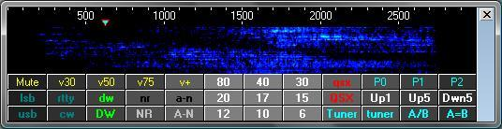

RCP\_8

### 4.4 Examples of Combined Macros

Set up a “split” operation based on the frequency in the A VFO

### 4.4.1. Kenwood TS-850

$command FB#split 05#;$

where (in this case) the 05 represents 5KHz offset. Note also the semi colon between the final # and $ characters

This will take the frequency from the "Active" VFO add the KHz offset and place the resultant in the B VFO.

**Note:** If the A VFO is "active" at the time and the Macro is repeated several times then the resultant in the B VFO store will remain the same. However IF the B VFO is active at the time then the B VFO will step up 5KHz for every application of the macro. This effect can be reversed if the command is changed from FB rather to FA

### 4.4.2. Yaesu FT-920

$hexcommand 00 00 00 01 01$ Sets FT-920 to Split mode

$hexcommand #spleeet+0h# 8A$ Sends FT-920 VFO-A freq to VFO-B (A>B)

$qsy#split+10#$ Increments FT-920 VFO-A by 10 kHz

$hexcommand #spleeet+10h# 0A$ Increments FT-920 VFO-A by 10 kHz (A+10)

$hexcommand #spleeet+10h# 8A$ Sends FT-920 VFO-A+10kHz to VFO-B (A+10 > B)

**Note**: When Logger32 polls The FT-920 for Frequency and Mode of VFO-A, it only reports the correct frequency and Mode if the radio is in VFO mode. If the radio is in MEM, M-TUNE or QMB, an error flag will pop up on the RCP spectrum and the bottom of the radio de-bug window. This flag advises the operator to turn off the MEM. M-TUNE or QMB as appropriate.

### 4.4.3. Yaesu FT1000mp

$hexcommand 00 00 00 00 85$ copy A VFO frequency and mode to B VFO

$hexcommand #split+5h#8A$ VFO A plus offset pushed into B VFO

$hexcommand 00 00 00 01 83$ turn ON dual mode receive

$hexcommand 00 00 00 01 01$ turn on split mode in ft1000mp

or combined

$hexcommand 00 00 00 00 85 #split+5h#8A 00 00 00 01 83 00 00 00 01 01$

### 4.4.4. Yaesu FT2000

$command FB#split 05#;$

This acts a little differently when applied to the FT2000. It takes the freq from the A VFO and increases the frequency by the offset and applies it to the B VFO

If the command is changed to read

$command FA#split 05#;$

Then it acts as the TS-850 and steps the A VFO up by the offset for each application of the Macro. So, a complete Macro to take a freq in the A VFO and make sure that the freq and mode for the QSX is correct will be:

$command AB;$ Copy A VFO to B VFO-To make frequencies and more importantly the MODES the same

$command FB#split 05#;$ Take A VFO freq add the offset and push to the B VFO

$command FT3;$ TX on the B VFO

$command FR2;$ Turn ON both the main and sub receivers

For the FT2000, exactly the same result can be obtained another way

$command AB;$ Copy A VFO to B VFO- To make frequencies and MODES the same.

$command EX033+05;$ Set the offset value in the menu settings for the QS function

$command QS;$ Select quick split option

$command FR2;$ Turn ON both the main and sub receivers

### 4.4.5 Elecraft K3

**Method 1** - Using the new #split# function :

$command K31;FT0;SWT13;FB#split+1#;SWH13;$

Where

K31: sets K3 mode

FT0: sets TX VFO to VFO A This always reset to VFO A before sending split command.

SWT13: transfers VFO A to VFO B (VFO A = VFO B)

FB#split+1#: sets VFO B +1KHz

SWH13: sets radio Split mode ON

**Method 2** - Using K3 commands:

$command K31;FT0;SWT13;FT1;UPB4;$

Where

K31: sets K3 mode

FT0: sets TX VFO to VFO A

SWT13: transfers VFO A to VFO B (VFO A = VFO B)

FT1: sets TX VFO to VFO B

UPB4: sets VFO B to up 1KHz (UPB5 = +2KHz, UPB6 = +3KHz, UPB7 = +5KHz)

### 4.4.6. ICOM IC-735

$hexcommand FE FE 04 E0 05 #split+10h#FD$ Increments IC-735 active VFO by

10 kHz

### 4.4.7. ICOM IC-7600

$hexcommand FE FE 7A E0 0F 01 FD$ Split ON

$hexcommand FE FE 7A E0 07 b1 FD$ VFO A=B

$hexcommand FE FE 7A E0 05 #split-10# FD$ Define fixed split 10 Kcs Down.

$hexcommand FE FE 7A E0 07 b0 FD$ VFO A/B

Example Setup Macros for split from keyboard:

$hexcommand FE FE 7A E0 0F 00 FD$ split off

$hexcommand FE FE 7A E0 07 b1 FD$ vfo A=B

$hexcommand FE FE 7A E0 0F 01 FD$ Split ON

$hexcommand FE FE 7A E0 05 #keyboard# FD$ Up/Dn(xx)

$hexcommand FE FE 7A E0 07 b0 FD$ VFO A/B

**Note**: The examples given above are known to function with the specified radios. However users will have to consult with their own radio operating or CAT manual for other models as the commands and parameter formats vary.

### 4.4.8 Kenwood TS-590

The following Macro will set the radio into split mode with QSX applied to VFO B.

$command VV;$ copy VFO A to VFO B (Freq and Mode)

$command FT1;$ Turm Split mode ON

$command #modeModifier#FB#DXSpotSplit#;$ Set VFO B Freq

Undo Split

$command FT0;$ Turn Split mode OFF

### 4.4.9.Kenwood TS-990

The following Macro will set the radio into split mode with QSX applied to the Sub Band.

$command VV;$ copy MAIN BAND to SUB BAND (Freq and Mode)

$command TB1;$ Turn Split mode ON

$command #modeModifier#FB#DXSpotSplit#;$ Set SUB BAND Freq

Undo split

$command TB0;$ Turn Split mode OFF

The following Macros can be configured for RCP F-Key.

**Up 1 split**

$command SP1;

$command SP001;

**Up 2 split**

$command SP1;

$command SP002;

### 4.4.10 ICOM 746 PRO

$hexcommand FE FE 66 E0 0F 00 FD$ split off

$hexcommand FE FE 66 E0 07 A0 FD$ VFO A=B my RxVFO is always A

$hexcommand FE FE 66 E0 07 01 FD$ select VFO B

$hexcommand FE FE 66 E0 0F 01 FD$ Split ON

$hexcommand FE FE 66 E0 05 #dxspotsplit# FD$ Set Split from spot

$hexcommand FE FE 66 E0 07 b0 FD$ VFO A/B

$icomVFOB$ read VFO B

## 5.0 ADDITIONAL INFORMATION

Some of the detailed examples above have comments to the right of each command. These can be left in the Macro without adversely effecting performance.

As part of the ongoing multi-lingual efforts of Logger32, the syntax of the #splitxx# function has been expanded. #spleeetxx# is now acceptable.

For those who might like to know, all the set up data for this window is held in the file called RadioPanel.ini found in the default Logger32 directory.

When checked, the RCP (and other windows that respond to function keys) should be responsive to F1 - F10 keystrokes from outside Logger32.

## 6.0 AUTOMATIC DX SPOT SPLIT OPERATIONS

### 6.1 #dxspotsplit# Function

This function is used to try and interpret any "split" details found in comment column of a dxspot clicked on and to apply that information, if possible by automatically applying user defined Macros in which this function is used.

**Note**: Once the Split function is setup, the user can click on a DX Spot containing a split designation and the split function will be active even when the Radio Control Panel is closed.

One of the main problems when trying to implement this is the non standard way in which operators actually report split operation so in some cases it will work and in other not so. Logger32 will assume that frequencies reported are in KHz. In some cases it will also recognise a freq offset range and will calculate the mid position in this offset and use this for the setting of the split vfo. There has been a lot of testing and using live traffic via the clusters and to date the function acts correctly on reports like:

|  |  |
| --- | --- |
| up 1 | up 5-10 |
| up 01 | up 10 |
| DN 01 | DOWN 01 |
| DOWN1 | QSX 21260.50 |
| SPLIT +5 | Tnx up up up 5 |
| 59 qsx 21285-21290 | qsx 21084.00 |
| up-2 | dn-2 |
| Tnx 4 nu band! Up 1.45 | PSE QSX 1810-1825 |
| LONGPATH UP 3-5 | qsx 7081 Alain |
| WRK CQ,CQ UP 7012.9 | RX 18.159.0 |
| QSX 14.033.35 | 59 qsx 21.285-21.290 |
| QSX UP 1.25KHZ 599 |  |

Logger32 attempts to determine the mid freq of a report which shows a QSX freq. For example "59 qsx 21285-21290" will use a freq of 21287.50. This may not function as expected IF there are additions characters ( like a space) between the two figures in the report. In these cases the first of the two QSX frequencies is used.

The reports below do not work:

|  |
| --- |
| LP up I (<-- this is a caps I not the fig 1) |
| tnx band #4 - up 107 LP |
| Up 111 |
| QSX 1.55 |
| QSX 111 |

and there are, no doubt, many others that will not work either.

### 6.2 "#DXSpotSplit#"

The syntax is exactly the same as #keyboard#. The difference being one derives the split from what you type, the other from comments (always very difficult to interpret) from a DX Spot you clicked on.

Two user defined Macros are used in this process, one to be used if a split is detected in the comments text and the other to restore the radio if there is no split defined. Each of these can be turned off individually if desired - See [RCP-6](#RCP_6) above

These Macros are entered into the Setup RCP macros for DX Spot clicks..window seen below.. [See also [para 2.4](#2.4_DX_Spot_Macros) above].

The left hand side of the table is for Radio 1 and the right for Radio 2. The upper sections are for the Macro(s) required to undo a split operation while the lower sections are what has to be applied to the radio to set up the split operation.

### 6.3 #modeModifier# function

The #modeModifier# function provides for radio filter selection based on the mode of operation. This object of #modemodifier# is not simply to change receive bandwidth, but also to do more creative things like different AGC for different modes, different transmit filter bandwidths for different modes, turning off speech processors for digital modes, reducing output power for PSK, disable the microphone and enable accessory audio input for digital modes. Use your imagination.

The function must be embedded in a Macro as shown in the DX Spot split command (setup window - center section). The actual Macro will vary based on the radio type and CAT/CI-V command structure. The actual command sent to the radio is selected based on the interpretation table listed in the bottom section of the setup chart as shown below. A comma must follow each entry in the table, including the last entry.

A typical Macro to set the bandwidth on a Yaesu radio would be:

**Macro**: $hexcommand 00 00 00 #modeModifier# 8C$

**Filter table**: SSB=01,CW=02,RTTY=03,PSK31=04,

A typical CI-V Macro for ICOM radios would be:

**Macro**: $hexcommand FE FE xx E0 06 #mode# #modeModifier# FD$. Where xx=radio CI-V address

**Filter table**: SSB=01, CW=03, RTTY=02,PSK31=02

**Note**: ICOM uses the Mode command to set the bandwidth. The #mode# function reads the operating mode listed in the Logbook Entry window and sends the mode and bandwidth information in a single radio command.

The following is an example of the split setup for Elecraft K3 and Kenwood TS-590. The individual setup will have distinctive commands based on the radio type and associated CAT/CI-V command structure. Some samples of known types are listed in the charts below.

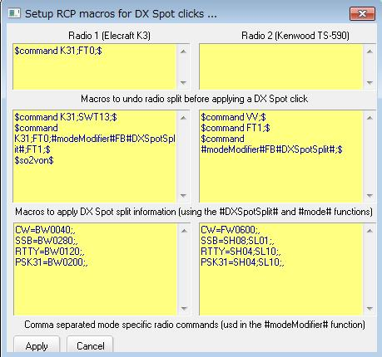

RCP\_9

**Note**: All of the Macros entered here will be radio dependent but some examples are given below as good starting points.

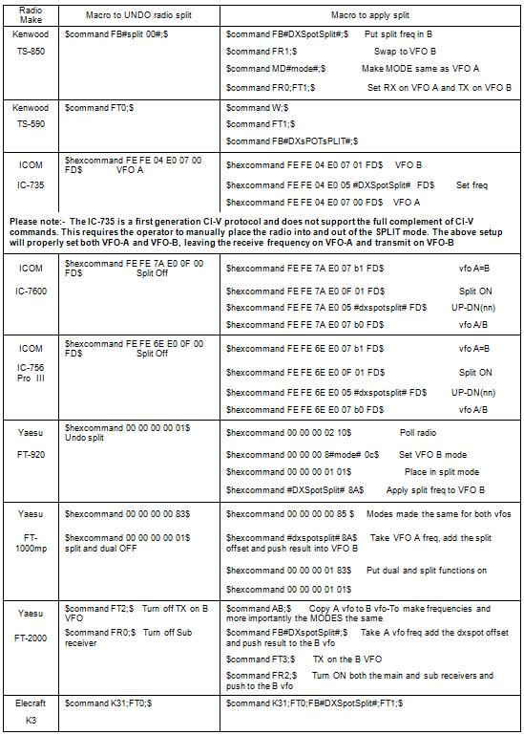

RCP\_10

6.4 $IcomVFOB$

To personalize the Macro, using the Logger32 [Main menu](#_topic_MainMenu) item, select [Setup | Radio | Radio x Configuration](#5.0_RADIO_MENU_ITEM) and then the <**Custom Settings**> button.

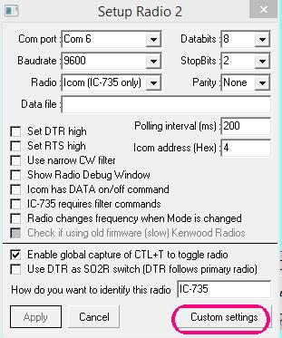

RCP\_26

This will open a setup widow where you can see four ICOM commands. The xx represents the ICOM radio CI-V address . overwrite the XX in each command with the specific Hex address of your ICOM radio.

The default CI-V commands shown initially are for the IC-7000. The CI-V commands should work with most late model ICOM radios. The user will need to verify the actual command for the radio type in use.

They are in order:

* 1. Switch to VFO-B
  2. Poll frequency
  3. Poll Mode
  4. Switch to VFO-A

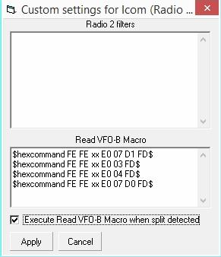

RCP\_27

Setup the Macro with correct address for your radio and if you like check the Execute Read VFO-B Macro when split detected check box. If you're lucky, your ICOM (if it is a more modern one) will read the VFO-B frequency/mode every time you put the radio in split. Also, if you setup a Macro button on the RCP with the $IcomVFOB$ Macro, you can update the VFO-B reading at will.

The following pictures show how to setup the split Macro these samples are for the IC-7600 commands.

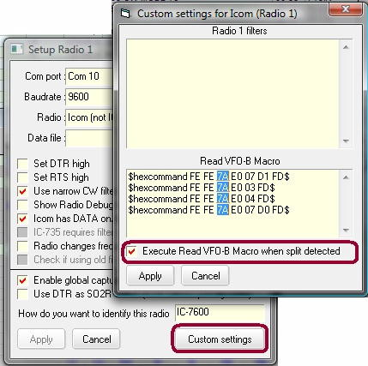

RCP\_28

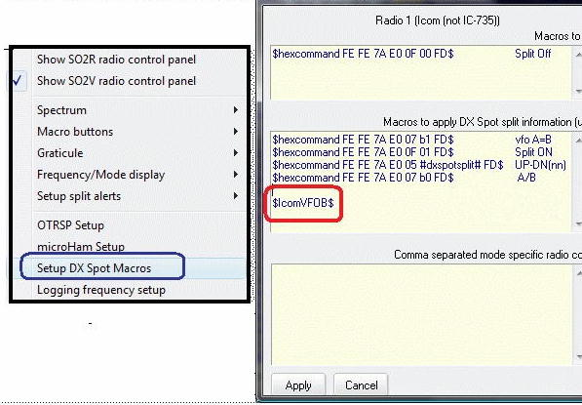

RCP\_29

**Note** that ICOM radios don’t have specific command for reading Frequency and Mode in sub VFO as other radios can do. This new ICOM Macro helps to read the frequency and mode, but can’t do a tracking of the frequency while in normal split operation we are changing the VFO-B frequency. It will be necessary occasionally refresh with the $IcomVFOB$ macro.

The following RCP panel shows Both VFOs during operation.

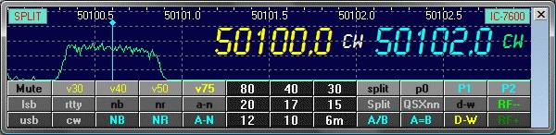

RCP\_30

## 7.0 ALERTS FOR SPLIT OPERATION

The user can enable visual and audio alerts when the radio has been placed in Split mode following a DX Spot selection that contains comments that meet the [qualifying Split syntax](#6.1__#dxspotsplit#_Function).

### 7.1 Visual Alert

To setup the Visual alert function, you have two choices.

**Note**: The user can select not only font forecolor and background color but font name, style and size. The Visual Alert Window size is automatically adjusted.

### 7.1.1 Setup in Radio Control Panel

Right click on side bar. Select “Setup split alerts” and then select “Visual alert font & color” or “Visual alert backcolor”.

The user can configure the text and background colors. The visual alert will continue to display until the split function is disabled. It can be limited to 5-second display by selecting the line “Limit visibility to 5 seconds”.

To enable the Visual alert function, select the line “Enable visual notification when radio split detected".

If the user wants to position Visual Alert Window anywhere then select the “Unlock Visual Alert from Logbook Entry Window” option and drag the window.

If the user wants to position the Visual Alert Window within the [Logbook Entry window](#_topic_LogbookEntryWindow) then deselect the “Unlock Visual Alert Window from Logbook Entry Window” option. The Visual Alert Window is always positioned at title bar of the Logbook Entry window.

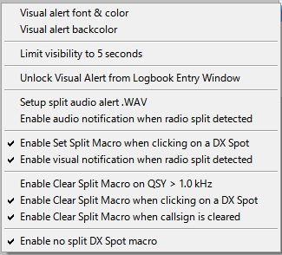

RCP\_11

When split visual alert has been initiated by selecting a DX Spot with the [qualifying Split syntax](#6.1__#dxspotsplit#_Function) in the comments, the [Logbook Entry window](#_topic_LogbookEntryWindow) will provide a visual indication.

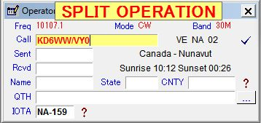

RCP\_12

### 7.1.2 Setup in Visual Alert Window

If the Visual Alert Window is visible then right click on this window.

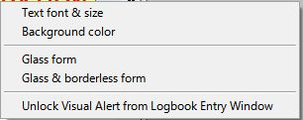

RCP\_12A

* + **Text font & size**: setup text font, forecolor and size
  + **Background color**: setup text background color
  + **Glass form**: set transparent form
  + **Glass & borderless form**: set transparent form without border line
  + **Unlock Visual Alert from Logbook Entry Window**: if this option is checked then the Visual Alert Window can be positioned anywhere.

### 7.2 Audio Alert

To setup the split Audio alert, open Setup and select “DX Spot Macros | Setup audio alert.wav”. This will open another pane where the audio wave file is selected.

To enable the audio alert click on the line “Enable audio notification when split macro executed”

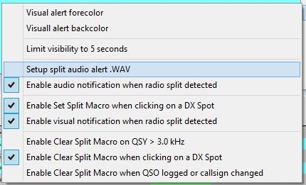

RCP\_13

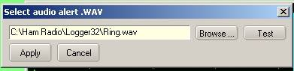

RCP\_14

### 7.3 Clear on QSY Option

When checked, the Logbook Entry window will clear, and if in "Split" mode, the radio will revert to Simplex operation.

## 8.0 SO2R AND SO2V OPERATION

The Radio Control Panel supports SO2R and SO2V operation much the same as the Sound Card. **Note:** For installation setup, see the topics [SO2R support](#_topic_SingleOperatorTwoRadiosSO2RSuppo) and [SO2V support](#_topic_SingleOperatorTwoVFOsSO2VSupport).

SO2V support is only available for radios with a second receiver.

To Select SO2R/SO2V operation right click on the right side of the Radio Control panel and select “Show SO2R radio control panel” or “Show SO2V radio control panel”

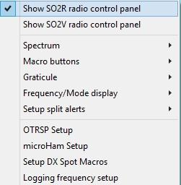

RCP\_15

This will open up a second Radio Control Panel.

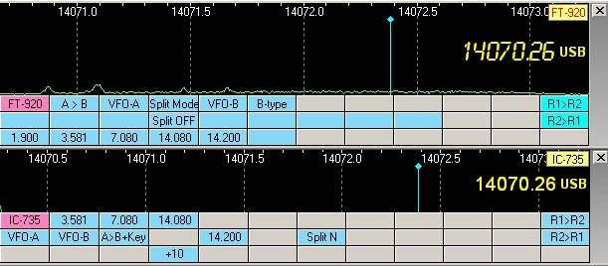

RCP\_16

In the above example, the VFO frequency and mode of the radio is displayed on the right side. This display is optional and the appearance can be adjusted for font, color, size and position.

The appearance of the Radio Control Panel can be enhanced by the use of special fonts. The upper pane above is a variation of an LCD display. The font is copyrighted, but is available as Freeware at: http://www.spinwardstars.com/scrfonts/.

The Radio type label shown in the upper right hand corner is user configurable. See the [Setup Radio Control](#_topic_SetupRadioControl) topic.

To configure the Frequency and mode, open: “Frequency/Mode display > Frequency/Mode appearance”. This will bring up a Frequency display setup chart

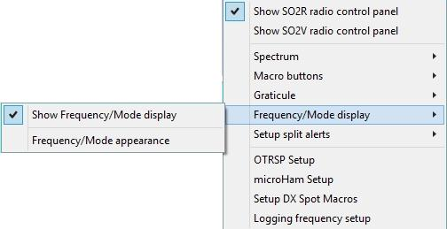

RCP\_17

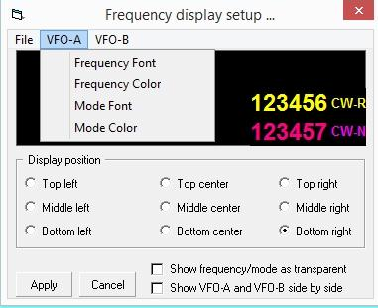

RCP\_18

### 8.3 OTRSP Setup

Users can now set up customized OTRSP commands that are automatically sent when the radio is switched with <**Ctrl+T**> or mouse click. The format follows that of OTRSP Macros - THIS|AND|THAT.

**Note**: See OTRSP hardware operation and setup.

To access the setup panel, select "OTRSP Setup" from the RCP Menu

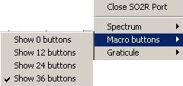

RCP\_19

This will open up the OTRSP Radio switching and keyboard commands dialog box where the radio specific macros can be configured.

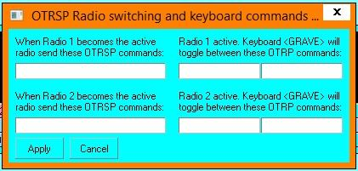

RCP\_20

As with Radio Control Panel DX Spot SPLIT/UNSPLIT Macros, this is a set once and forget setting. Once it is set up the way the user likes, the Radio Control Panel need not be open for the Macros to function.

### 8.4 Setup of DX Spot QSX Notices

Logger32 has a facility to automatically log split frequencies add QSX frequency to the “Comments” section of the DX Spots.

This capability is implemented for radios with dual receivers and some radios with independent VFO-A and VFO-B. The radio must have the CAT capability to reply to a simple poll and include Frequency and mode for both VFOs.

**Note**: Logger32 has a limitation of 100 Khz in split mode. If the QSX exceeds 100 KHz, it will be ignored.

However the QSO can be logged with greater splits such as cross band operation.

To configure the DX Spot <**Ctrl+D**>, from the Logger32 [Main menu](#_topic_MainMenu) select the [Setup | DX Spot](#11.0_DX_SPOT_MENU_ITEM) menu items and check the two bottom options.

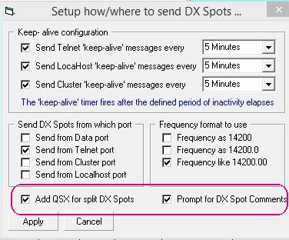

RCP\_21

### 8.5 Setup Split Frequency Logging

Open the RCP Menu and select “Logging Frequency Setup”. This will open pane where you select desired options.

**Note**: Logger32 will log both TX and RX frequencies. Too make both frequencies visible, you must add the ADIF field “FREQ\_RX” to the logbook grid.

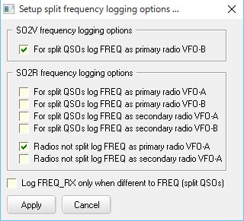

RCP\_22

### 8.6 Flags and Indicators

The following is a typical RCP window. It shows the frequency of VFO-A (yellow) and VFO-B.

VFO-B will only display if the radio poll reply includes VFO-B data. The appearance size, color and position of the Frequency and Mode are user selected.

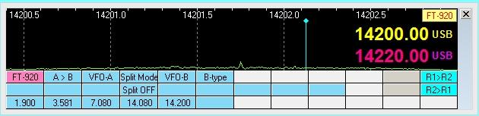

RCP\_23

The following shows that the radio is in split mode, as indicated in the upper left hand corner.

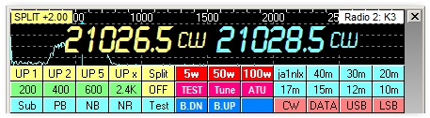

RCP\_24

It shows “SPLIT” + offset frequency differencial. You can change text color and back color for the Split/Radio label.

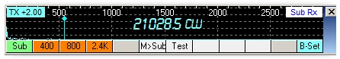

RCP\_24A

The following is an example of a SO2V setup. VFO-A is on the bottom (User preference) and VFO-B is on top. The radio is setup for split operation with transmit on VFO-B as indicated by the “TX” flag in the upper left hand corner. It shows “SPLIT” + offset frequency differencial. You can change text color and back color for the Split/Radio label..

This display also advises the user that the radio is in MEMORY mode and not in VFO mode. Some radios only return the VFO-A data in response of the Logger32 poll. If the radio is in MEM, M-Tune or a QMB channel, the frequency reported to Logger32 will be wrong. This notification is a blinking flag in the lower left corner of the spectrum display.

Currently this function applies to the Yaesu FT-920 and FT-1000. Others will be added as needed.

Radios react differently, leaving it up to the user to familiarize themselves with the operation of the radio in use.

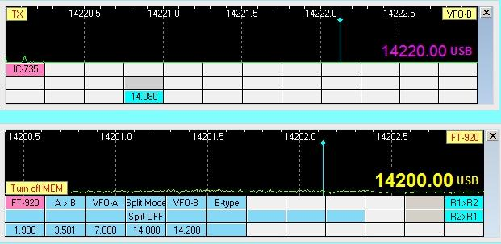

RCP\_25